GSM Adobe Commerce
HomePage Tracking Plan
Tracking and tagging plan for the Girl Scout Merchandise website on the Adobe Commerce platform. Based on the wireframes, designs, and block definitions from January 2026 in Phase 1 of the project.

Version: 2026-03-13

Page-Level Attributes

Adding Google Tag Manager (GTM)

Implementation Details

Dev / Staging
1. Paste this code as high in the <head> of the page as possible:
<!-- Google Tag Manager -->
<script>(function(w,d,s,l,i){w[l]=w[l]||[];w[l].push({'gtm.start':
new Date().getTime(),event:'gtm.js'});var f=d.getElementsByTagName(s)[0],
j=d.createElement(s),dl=l!='dataLayer'?'&l='+l:'';j.async=true;j.src=
'https://www.googletagmanager.com/gtm.js?id='+i+dl;f.parentNode.insertBefore(j,f);
})(window,document,'script','dataLayer','GTM-MSX7R7F4');</script>
<!-- End Google Tag Manager -->

2. Paste this code immediately after the opening <body> tag:
<!-- Google Tag Manager (noscript) -->
<noscript><iframe src="https://www.googletagmanager.com/ns.html?id=GTM-MSX7R7F4"
height="0" width="0" style="display:none;visibility:hidden"></iframe></noscript>
<!-- End Google Tag Manager (noscript) -->

Production
1. Paste this code as high in the <head> of the page as possible:

<!-- Google Tag Manager -->
<script>(function(w,d,s,l,i){w[l]=w[l]||[];w[l].push({'gtm.start':
new Date().getTime(),event:'gtm.js'});var f=d.getElementsByTagName(s)[0],
j=d.createElement(s),dl=l!='dataLayer'?'&l='+l:'';j.async=true;j.src=
'https://www.googletagmanager.com/gtm.js?id='+i+dl;f.parentNode.insertBefore(j,f);
})(window,document,'script','dataLayer','GTM-NXWW7L3J');</script>
<!-- End Google Tag Manager -->

2. Paste this code immediately after the opening <body> tag:
<!-- Google Tag Manager (noscript) -->
<noscript><iframe src="https://www.googletagmanager.com/ns.html?id=GTM-NXWW7L3J"
height="0" width="0" style="display:none;visibility:hidden"></iframe></noscript>
<!-- End Google Tag Manager (noscript) -->

DataLayer Push

Placement
This code must be placed above the GTM <script> tag in the <head> of the document.

Implementation Details
Object Path | Key | Data Type | Example | Notes
root | event | string | "page_init" | Bootstrap event. Fires once per page load.
environment | env | string | "production" | Controlled values: production, staging, qa, dev
environment | site | string | "gsusa_shop" | Stable site identifier. Low-cardinality.
environment | platform | string | "web" | Controlled values: web, mweb, ios_app, android_app
environment | version | string | "1.42.0" | Release/app version. Useful for debugging.
page | page_type | string | "homepage" | Controlled taxonomy (homepage, plp, pdp, cart, checkout, confirmation, search, account, etc.).
page | page_name | string | "pdp | daisy (grades k-1)" | consumer home, wholesale home, leader home
page | path | string | "/" | Should use window.location.pathname.
page | referrer | string | "https://google.com" | Use document.referrer. May be empty.
page | previous_page_path | string | "/checkout/confirmation" | Internal previous path if available. Do not infer from referrer.
page | title | string | "Girl Scouts Shop" | Use document.title.
page | language | string | "en-US" | From <html lang> or browser.
user | login_state | string | "logged_out" | Controlled: logged_in, logged_out
user | user_id | string | "u_7f3a91c2" | Gigya ID. Not email-derived. Null if not logged in.
user | user_type | string | "new_user" | Controlled: guest | new_user | returning_user | returned_customer – set to new new_user if account was created in the same day as session, returning_user if the user has no orders, returned_customer more than 1 order default to guess if non-known user
user | customer_type | string | "consumer" | Controlled: consumer, council administrator, vendor – be default set consumer, once the user identified based on login status or UX experience
user | audience_mode | string | "leaders” | Controlled: wholesale_partner | leaders | general. Set to leader if user toggles leader UX experience otherwise general
user | troop_id | string | “87” | Troop number of user.
user | council_id | string | “alaska…” | Council identifier.
user | em_sha256 | string | “lasidhgoaishdg” | User’s email, use SHA-256 encryption. Server-side only. Transmitted to ad platforms after Truyo consent granted.
user | ph_sha256 | string | “lasidhgoaishdg” | User’s phone, use SHA-256 encryption. Server-side only. Normalize: strip spaces/dashes/parens, include country code (+1).

Consumer Homepage
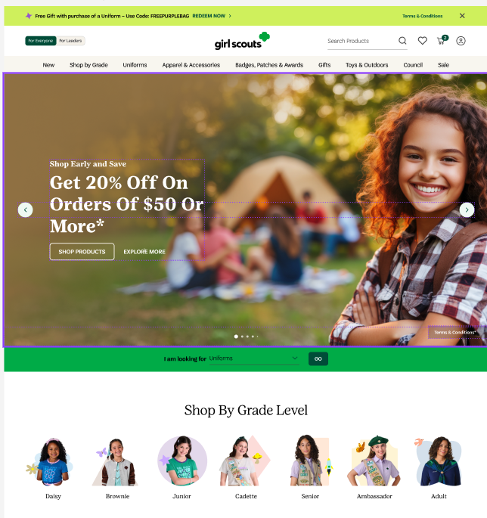

window.dataLayer.push({
event: "page_init",
environment: {
env: "production",
site: "gsusa_shop",
platform: "web",
version: "1.42.0"
},
page: {
page_type: "homepage",
page_name: "consumer home",
path: window.location.pathname,
referrer: document.referrer,
previous_page_path: '/checkout/confirmation'
title: document.title || null,
language: document.documentElement.lang || navigator.language || null
},
user: {
login_state: "logged_out",
user_id: null,
user_type: "guest",
customer_type: "council administrator",
audience_mode: "leaders”,
troop_id: null,
council_id: null,
em_sha256: null,
ph_sha256: null
}
}

wholesale
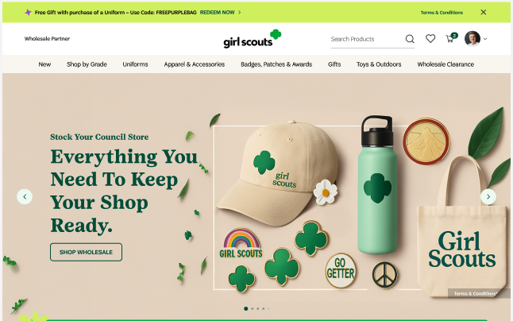
window.dataLayer.push({
event: "page_init",
environment: {
env: "production",
site: "gsusa_shop",
platform: "web",
version: "1.42.0"
},
page: {
page_type: "homepage",
page_name: "wholesale home",
path: window.location.pathname,
referrer: document.referrer,
previous_page_path: "/"
title: document.title || null,
language: document.documentElement.lang || navigator.language || null
},
user: {
login_state: "logged_in",
user_id: "ldagas435",
user_type: "repeat",
customer_type: "vendor",
audience_mode: "vendor",
troop_id: null,
council_id: null,
em_sha256: null,
ph_sha256: null
}
}

Leaders Flow

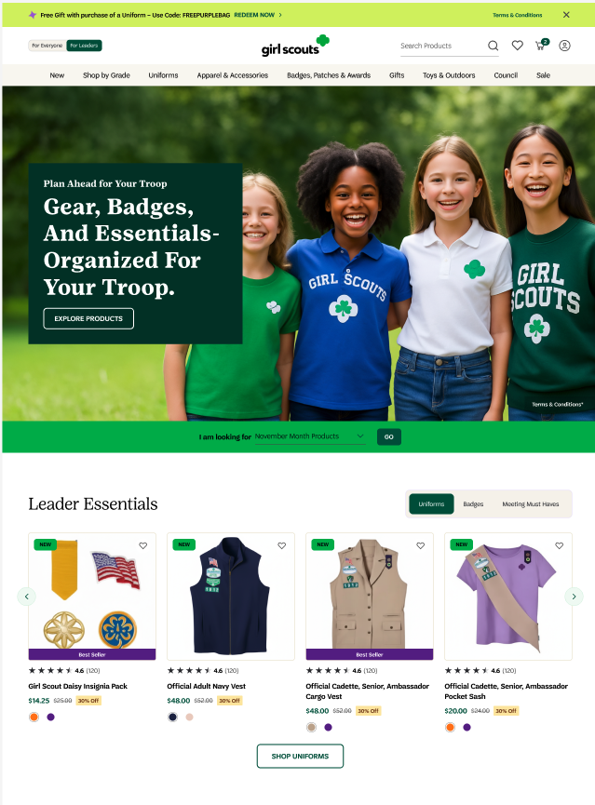
window.dataLayer.push({
event: "page_init",
environment: {
env: "production",
site: "gsusa_shop",
platform: "web",
version: "1.42.0"
},
page: {
page_type: "homepage",
page_name: "leaders home",
path: window.location.pathname,
referrer: document.referrer,
previous_page_path: "/"
title: document.title || null,
language: document.documentElement.lang || navigator.language || null
},
user: {
login_state: "logged_out",
user_id: "54dg4a,,
user_type: "repeat",
customer_type: "council administrator",
audience_mode: "leaders",
troop_id: null,
council_id: null,
em_sha256: null,
ph_sha256: null
}
});

Audience Toggle
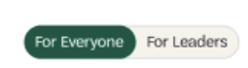

Business Questions
The tagging here will answer these questions.

- How many users are toggling between the two experiences?
- Does one experience convert at a higher rate than the other?
- Does one experience have a higher AOV than the other?

Implementation Details
Object Path | Key | Data Type | Example | Notes
root | event | string | "page_init" | Bootstrap event. Fires once per page load.
root | user | object | {} | User details
user | login_state | string | "logged_out" | Controlled: logged_in, logged_out
user | user_id | string | "u_7f3a91c2" | Gigya ID. Not email-derived. Null if not logged in.
user | user_type | string | "new_user" | Controlled: guest | new_user | returning_user | returned_customer – set to new new_user if account was created in the same day as session, returning_user if the user has no orders, returned_customer more than 1 order, set to guest if non-user
user | customer_type | string | "consumer" | Controlled: consumer, council administrator, vendor – be default set consumer, once the user identified based on login status or UX experience
user | audience_mode | string | "leaders” | Controlled: leaders | general. Set to leader if user toggles leader UX experience otherwise general

dataLayer.push({
event: "audience_toggle",
user: {
login_state: "logged_out",
user_id: null,
user_type: "guest",
customer_type: "consumer",
audience_mode: "leaders",
troop_id: null,
council_id: null,
em_sha256: null,
ph_sha256: null
}
});

Nav / Footer Tracking
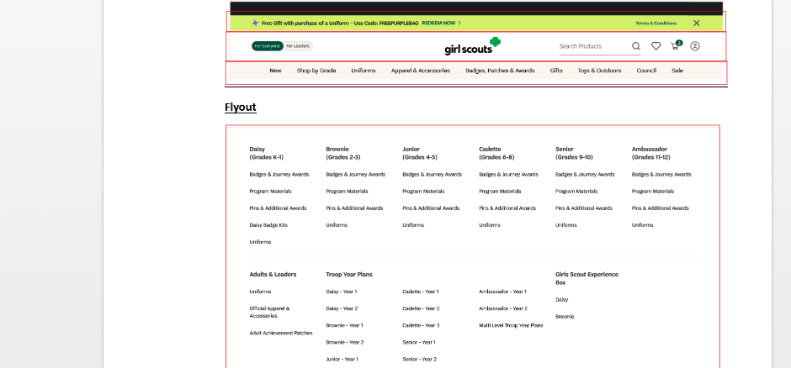
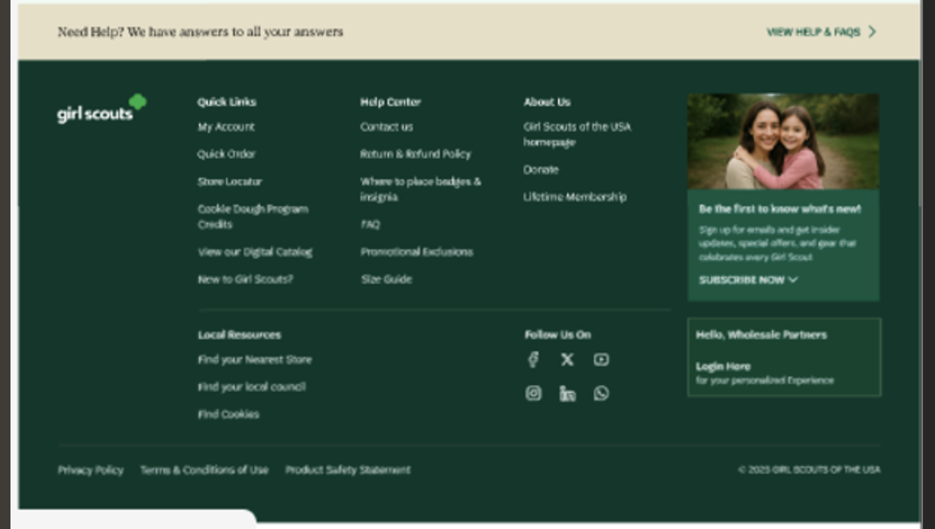

Business Questions
The tagging here will answer these questions.

- How are users navigating the site?
- Which primary nav items are most clicked?
- What percentage of users use navigation vs search?
- Are users finding what they need through navigation?
- Do nav clicks lead to deeper engagement?
- Do users bounce after certain nav paths?
- Is navigation aligned with user intent?
- Are high-demand sections buried?
- Are low-value links consuming prime space?
- Where do users drop off after navigating?
- Are some nav links leading to dead ends?
- Are category pages weak?
- Are users clicking the same nav item repeatedly?
- Indicates confusion or page not updating properly.
- Are mobile users navigating differently than desktop users?

Implementation Details

Add data-attributes* to clickable elements

Attribute | Data Type | Requirement / Rule | Examples
data-analytics-type | string | Required. Defines the UI component style. Must use a fixed, controlled vocabulary to avoid fragmentation. | nav, footer
data-analytics-location | string | Required. Defines the visual zone where the element appears. Use predefined zones only. For menus, always specify context (e.g., header vs flyout). | header, flyout
data-analytics-item | string | Required. Canonical identifier for the link. Use lowercase, kebab-case slugs. Must remain stable even if UI text changes. | uniforms, account-settings, store-locator
data-analytics-destination | string | Required. Target URL or action. Use relative paths for internal links. Use short action names for non-navigation actions. | /shop/new, /login

Example Code:
<a
href="/shop/new_uniforms"
data-analytics-type="nav"
data-analytics-location="header"
data-analytics-item="new_uniforms"
data-analytics-destination="/shop/new_uniforms"
>
New Uniforms
</a>

Errors

Business Questions
The tagging here will answer these questions.

- What % of homepage loads have errors?
- Which module fails most frequently?
- Are API failures hurting engagement?
- Is error rate higher in specific environments?
- Does error rate correlate with revenue drop?

Implementation Details
- Fire only when the error is visible or user-impacting
- Do not include stack traces
- Do not include request payloads
- Keep error codes stable and reusable
- One event per failure instance

Object Path | Key | Example | Notes
root | event | "error_event" | Standard event name
page | page_type | "homepage" | Must match controlled taxonomy
error | error_type | "api" | Controlled values
error | error_code | "HP_MODULE_TIMEOUT" | Stable internal code
error | severity | "warning" | blocking | warning
context | module | "hero_board" | Affected module
context | action | "initial_load" | Triggering action

window.dataLayer.push({
event: "error_event",
error: {
error_type: "api",
error_code: "HP_MODULE_TIMEOUT",
error_message: "Hero module failed to load",
error_field: "",

severity: "warning"
},
context: {
page_type: "homepage",
module: "hero_board",
action: "initial_load"
}
});

Hero Board block
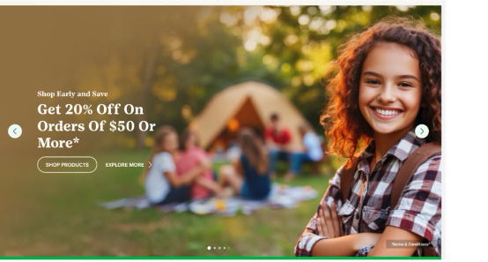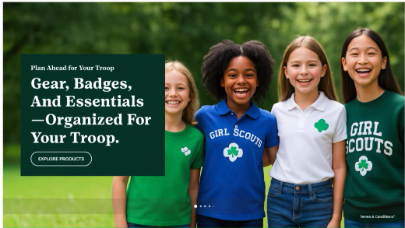

Business Questions
The tagging here will answer these questions.

- Are users engaging with the hero at all?
  - What is the hero CTR?
  - What percentage of users scroll past without interacting?
- Which hero creative drives the most clicks?
  - Performance by promo ID
  - Performance by creative label
- Does hero position matter? (if carousel)
  - Is Slide 1 outperforming Slide 2?
  - Is there position bias

Implementation Details
Impression

Attribute | Data Type | Requirement / Rule | Example
data-analytics-type | string | Defines the UI component type | impression
data-analytics-kind | string | Identifies content category. Used to detect promos deterministically. | promo, creative
data-analytics-location | string | Page zone where component appears | hp
data-analytics-module | string | Logical grouping of component | hero
data-analytics-position | integer | Visual position within module | 1, 2, 2003
data-analytics-label | string | Human-readable identifier (normalized) | cookie-season-launch
data-analytics-id | string | Stable internal campaign/promo ID | hp_hero_cookie-season-launch
data-analytics-destination | string | Target URL path | /shop/cookies

Clickable item

Attribute | Data Type | Requirement / Rule | Example
data-analytics-type | string | Defines the UI component type | cta
data-analytics-kind | string | Identifies content category. Used to detect promos deterministically. | promo, creative
data-analytics-location | string | Page zone where component appears | hp
data-analytics-module | string | Logical grouping of component | hero
data-analytics-position | integer | Visual position within module | 1, 2, 2003
data-analytics-label | string | Human-readable identifier (normalized) | cookie-season-launch
data-analytics-id | string | Stable internal campaign/promo ID | hp_hero_cookie-season-launch
data-analytics-destination | string | Target URL path | /shop/cookies

Example Code:
<section
class="hero-board"
data-analytics-type="hero_promo"
data-analytics-kind="promo"
data-analytics-location="hp_hero"
data-analytics-module="20_percent_off"
data-analytics-position="1"
data-analytics-label="cookie-season-launch"
data-analytics-id="promo_2026_20_perf"
data-analytics-destination="/shop/cookies">
<a href="/shop/cookies">
<img src="/images/cookie-hero.jpg" />
</a>
</section>

Hero Board – Carousal
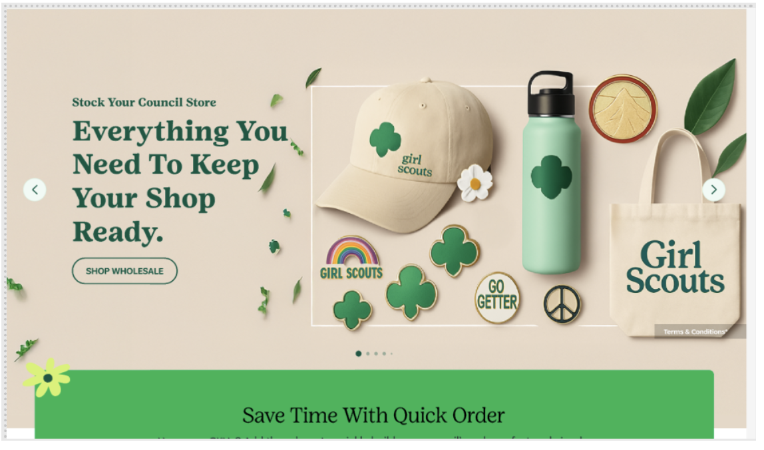

Implementation Details
Impression
Attribute | Data Type | Requirement / Rule | Example
data-analytics-type | string | Defines the UI component type | impression
data-analytics-kind | string | Identifies content category. Used to detect promos deterministically. | promo, creative
data-analytics-location | string | Page zone where component appears | hp
data-analytics-module | string | Logical grouping of component | hero
data-analytics-position | integer | Visual position within module | 1, 2, 2003
data-analytics-label | string | Human-readable identifier (normalized) | cookie-season-launch, cookie-season-launch_2, cookie-season-launch_3 list all the creatives in the carousal
data-analytics-id | string | Stable internal campaign/promo ID | hp_hero_carousal
data-analytics-destination | string | Target URL path | /shop/cookies
Clickable items
Attribute | Data Type | Requirement / Rule | Example
data-analytics-type | string | Defines the UI component type | cta
data-analytics-kind | string | Identifies content category. Used to detect promos deterministically. | promo, creative
data-analytics-location | string | Page zone where component appears | hp
data-analytics-module | string | Logical grouping of component | hero
data-analytics-position | integer | Visual position within module | 1, 2, 2003
data-analytics-label | string | Human-readable identifier (normalized) | cookie-season-launch1
data-analytics-id | string | Stable internal campaign/promo ID | hp_hero_carousal
data-analytics-destination | string | Target URL path | /shop/cookies

Guided Navigation Selector block

Business Questions
The tagging here will answer these questions.

- Are users struggling to find content through navigation?
- How many searches return zero results?
- Are users repeatedly searching for the same term?
- Do users abandon after searching?
- What are users actively looking for?
- Is search behavior aligned with business priorities?

Implementation Details
dataLayer Push Fire when:
- User clicks GO OR presses Enter to trigger the search request
On Click

Object | Parameter Name | Data Type | Example Value | Description
root | event | string | "search" | Event name pushed to dataLayer
search | search.term | string | "uniforms" | Search keyword entered or selected
search | search.method | string | "selector" | How the search was initiated (manual input, selector, autocomplete, guided nav)
search | search.location | string | "header" | Page location where search was initiated
search | search.module | string | "guided_navigation" | Module or UI component responsible for the search interaction
search | search.destination | string | "/feature_quick_order" | Destination of search results
page | page.pagePath | string | / | Current page path
page | page.pageType | string | "homepage" | Logical page classification

Search Results:

Object | Parameter Name | Data Type | Example | Description
root | event | string | "view_search_results " | Name of the dataLayer event
search | search.term | string | "uniforms" | Search keyword entered or selected
search | search.method | string | "selector" | How search was initiated (manual, autocomplete, selector, guided_navigation)
search | search.location | string | "header" | UI location where search was triggered
search | search.module | string | "guided_navigation" | Specific component responsible for interaction
search | search.element | string | "search_input" | Specific UI element interacted with (input field, icon, button)
search | search.results_count | integer | 10 | Number of results returned for the query
search | destination | string | "/feature_quick_order_2026” | Destination URI

Example Code:
On Search
window.dataLayer.push({
event: "search",
search: {
term: "uniforms",
method: "selector",
location: "header",
module: "guided_navigation",
search_element: "drop_down",
search_result_count: null,
destination: "/feature_quick_order_2026"
},
page: {
pagePath: window.location.pathname,
pageType: "homepage"
}
});

Results
On page load.

window.dataLayer.push({
event: "page_init",
environment: {
env: "production",
site: "gsusa_shop",
platform: "web",
version: "1.42.0"
},
page: {
page_type: "/feature_quick_search",
page_name: "plp | search",
path: window.location.pathname,
referrer: document.referrer,
previous_page_path: "/"
title: document.title || null,
language: document.documentElement.lang || navigator.language || null
},
user: {
login_state: "logged_out",
user_id: "54dg4a,,
user_type: "repeat",
customer_type: "council administrator",
audience_mode: "leaders"
}
}

window.dataLayer.push({
event: "view_search_results",
search: {
term: " view_search_results",
method: "selector",
location: "header",
module: "guided_navigation",
search_element: "drop_down",
search_result_count: 10,
destination: "/feature_quick_order_2026"
},
page: {
pagePath: window.location.pathname,
pageType: "homepage"
}
});

Feature Banner / In-PageBanner / Campaign Highlights Carousel / Home page Blocks / Small Info Callout
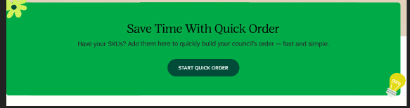
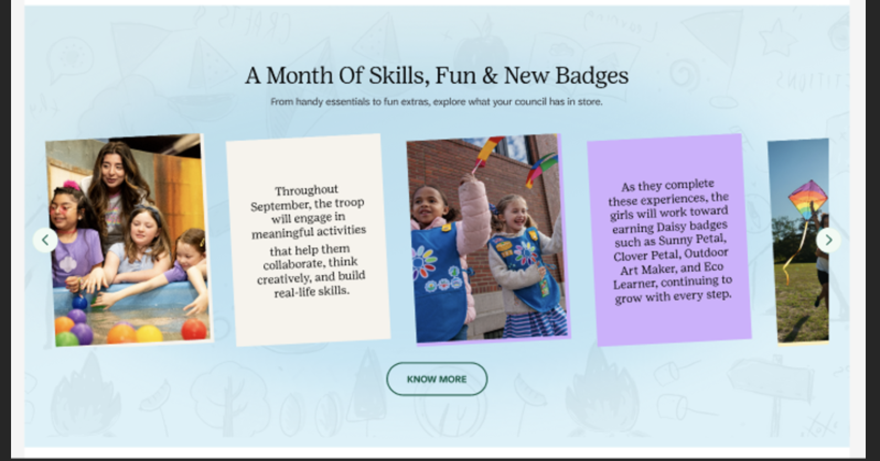
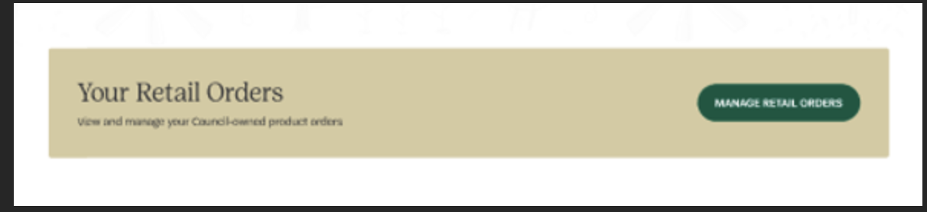
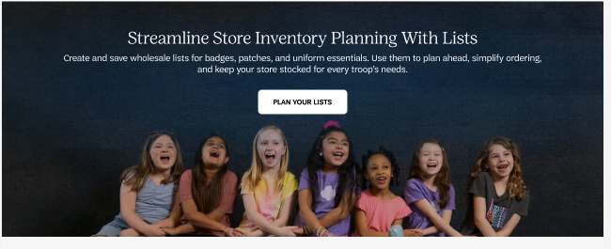
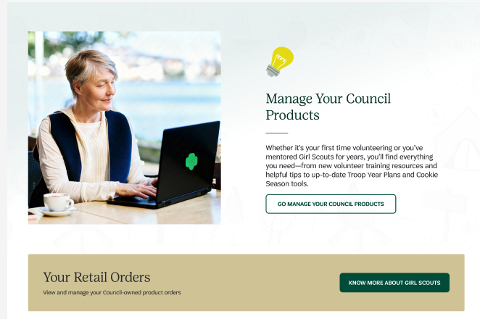
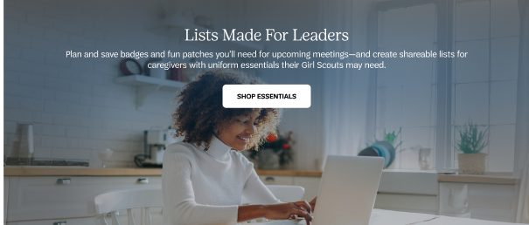

Business Questions
The tagging here will answer these questions.

- Are users engaging with HP modules?
- What is the CTR of the HP modules?
- Does hero exposure increase tool adoption?
- Do Quick Order users convert at a higher rate?
- What is the AOV from Quick Order sessions?
- Does Quick Order reduce checkout friction?
- Are users engage with Plan you List?

Implementation Details
Impression
Attribute | Data Type | Requirement / Rule | Example
data-analytics-type | string | impresion | impression
data-analytics-kind | string | Required. Classifies CTA (feature, promo, utility, content). | "feature"
data-analytics-location | string | Required. Logical placement on page. Must follow naming convention (e.g., hp_hero, hp_nav). | "hp_hero" | "banner" | “inpage_banner” | “campaign_highlights_carousel” | managing lists | council product etc.
data-analytics-module | string | Required. Identifies functional grouping or feature group. | "quick_order"
data-analytics-position | integer | Required. Positive integer. Position index within module starting at 1. | 1
data-analytics-label | string | Required. Human-readable slug. Lowercase, hyphen-separated, no spaces. | "save-time-quick-order"
data-analytics-id | string | Required. Globally unique identifier. Should include type + module + version/year. | "feature_quick_order_2026"

Clickable items

Attribute | Data Type | Requirement / Rule | Example
data-analytics-type | string | Required. Must use controlled value (cta, hero_cta, nav_cta, etc.). | "cta"
data-analytics-kind | string | Required. Classifies the CTA (feature, promo, utility, content). | "feature"
data-analytics-location | string | Required. Logical placement on page using naming convention (hp_hero, hp_nav, plp, pdp). | hp_hero" | "banner" | “inpage_banner” | “campaign_highlights_carousel” etc.
data-analytics-module | string | Required. Functional grouping or feature area. | "quick_order"
data-analytics-position | integer | Required. Positive integer. Position within module starting at 1. | 1
data-analytics-label | string | Required. Lowercase, hyphen-separated slug. No spaces. | "save-time-quick-order"
data-analytics-id | string | Required. Globally unique CTA identifier. Must remain stable across releases. | "cta_quick_order_start"
data-analytics-destination | string | Required. Destination path or URL triggered by click. Must match actual navigation target. | "/quick-order"
Add data-analytics-*
- The module container (for impressions)
- For Button (for clicks)

Impression
<section
data-analytics-type="hero_cta"
data-analytics-kind="feature"
data-analytics-location="hp_hero"
data-analytics-module="quick_order"
data-analytics-position="1"
data-analytics-label="save-time-quick-order"
data-analytics-id="feature_quick_order_2026">

Add attributes to the button
<button
data-analytics-type="cta"
data-analytics-kind="feature"
data-analytics-location="hp_hero"
data-analytics-module="quick_order"
data-analytics-position="1"
data-analytics-label="start-quick-order"
data-analytics-id="cta_quick_order_start"
data-analytics-destination="/quick-order">
Start Quick Order
</button>

Shop-By Navigator
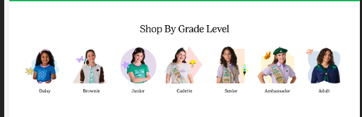

Business Questions
The tagging here will answer these questions.

- Which grade level is most selected from homepage?
- Are users browsing by grade or using navigation/search?
- Does grade-level browsing dominate homepage engagement?
- Does tile position impact click rate?
- Should higher-performing grades be reordered?
- Is this module driving meaningful engagement compared to hero?
- Are users shopping primarily for a specific grade?
- Does grade selection correlate with basket size?
- Do users return to homepage after entering a grade category?

Implementation Details
Add data-analytics-*
- The module container (for impressions)
- Each tile (grade level) (for clicks + position analysis)

Impressions
Attribute | Data Type | Requirement / Rule | Example
data-analytics-type | string | impression | "impression"
data-analytics-kind | string | Required. Defines strategic purpose (merchandising, utility, content, promo). | "merchandising"
data-analytics-location | string | Required. Logical page placement. Must follow standardized naming (homepage, plp, pdp). | "homepage"
data-analytics-module | string | Required. Functional grouping name. Lowercase, underscore-separated. | "shop_by_grade_level"
data-analytics-label | string | Required. Human-readable slug describing module. Lowercase, hyphen-separated. | daisy|brownie|..|adult list all the items found in the module
data-analytics-id | string | Required. Globally unique identifier. Should include module + year/version for governance. | "module_grade_level_2026"

Individual Grade for click tracking
Attribute | Data Type | Requirement / Rule | Example
data-analytics-type | string | Required. Must use controlled taxonomy value (e.g., category_tile, cta, nav). | "cta"
data-analytics-kind | string | Required. Defines strategic intent (merchandising, utility, content, promo). | "merchandising"
data-analytics-location | string | Required. Logical page placement using standardized naming convention. | "homepage"
data-analytics-module | string | Required. Must match parent module wrapper exactly for proper attribution. Lowercase, underscore-separated. | "shop_by_grade_level"
data-analytics-position | integer | Required. Positive integer. Position within module starting at 1. | 1
data-analytics-label | string | Required. Lowercase, hyphen-separated slug representing tile value. | "daisy"
data-analytics-id | string | Required. Globally unique and stable identifier. Should not change unless tile is materially redefined. | "module_grade_level_2026"

For Impression
<section
data-analytics-type="category_selector"
data-analytics-kind="merchandising"
data-analytics-location="homepage"
data-analytics-module="shop_by_grade_level"
data-analytics-label="daisy|brownie|junior|cadette|senior|ambasador|adult"
data-analytics-id="module_grade_level_2026">

Individual Grade for click tracking
<a
href="/shop/grade/daisy"
data-analytics-type="category_tile"
data-analytics-kind="merchandising"
data-analytics-location="homepage"
data-analytics-module="shop_by_grade_level"
data-analytics-position="1"
data-analytics-label="daisy"
data-analytics-id="module_grade_level_2026"
data-analytics-destination="/shop/grade/daisy">
Daisy
</a>

Collection Carousels / Recent Product / Program Product Feed / Recommended Products / Your Recent Orders

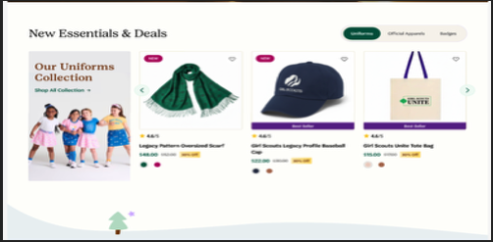
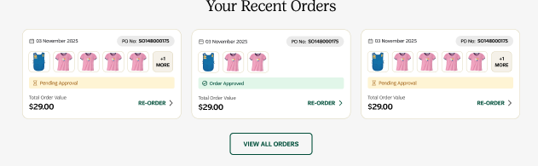

Business Questions
The tagging here will answer these questions.

- What is the revenue per homepage module
- Is there product position bias
- What View-to-cart rate by slot
- What Performance of “New Essentials” vs other modules
- What is ROI of homepage merchandising
- Assortment effectiveness?

Implementation Details
dataLayer Push: this should fire after the product data is available AND the module becomes visible.
Deployed instructions: Wait until product data is fully resolved
Wait until the module is visible in viewport (50% recommended)
Fire once per page load

Object Path | Key | Data Type | Example | Notes
root | event | string | "view_item_list" | Required, when user enter view port and items are available. Default value: "view_item_list"
page | page_type | string | "plp" | Controlled taxonomy. Must match page_init value.
page | page_name | string | "PLP – Daisy’s" | Stable internal label. Not display copy.
item_list | list_type | string | recent_viewed | List type
item_list | list_id | string | recent_viewed | Unique list name (category name)
item_list | List_name | string | "Recent Viewed" | Friendly name of list
ecommerce |  |  |  | Required. Full items from original order.
ecommerce | currency | string | "USD" | Required.
ecommerce { } | value | number | 29.00 | Required. Order value.
ecommerce { } | coupon | string | Welcome25 | Coupon used for discount
ecommerce { } | items | array | [{...}] | Required. Full items[] — same schema as add_to_cart.
ecommerce.items[] | index | integer | 0 | Product position of item
ecommerce.items[] | item_id | string | "SKU_10002" | Required. ID/Sku of the product
ecommerce.items[] | item_parent_sku | string | "SKU_10002" | Required. ID/Sku of the parent sku
ecommerce.items[] | line_group_id | string | "L001" | Required. shared ID code used to tie a primary product to all of its variations, modifications, and optional add-ons
ecommerce.items[] | item_type | string | "product" | Required. product | service_cost | customization.
ecommerce.items[] | item_name | string | "Official Adult Recycled Vest" | Required. Product Name
ecommerce.items[] | item_brand | string | "Girl Scouts" | Recommended. Product brand
ecommerce.items[] | item_category | string | "Apparel" | Recommended. Product category top level
ecommerce.items[] | item_category2 | string | null | Optional. Product category top level sub-level
ecommerce.items[] | item_category3 | string | null | Optional. Product category top level sub-level
ecommerce.items[] | item_category4 | string | null | Optional. Product category top level sub-level
ecommerce.items[] | item_category5 | string | null | Optional. Product category top level sub-level
ecommerce.items[] | list_type | string | recent_viewed | List type
ecommerce.items[] | list_id | string | plp_recent_viewed | Unique list name (category name)
ecommerce.items[] | list_name | string | "PLP - Recent Viewed" | Friendly name of list
ecommerce.items[] | item_variant | string | "Blue / M" | Optional. Variant from original order.
ecommerce.items[] | original_price | number | 54.00 | CONDITIONAL. Required when discounted.
ecommerce.items[] | discount_price | number | 44.00 | Optional. Discount price
ecommerce.items[] | price | number | 44.00 | Required. Price paid in original order.
ecommerce.items[] | wholesale_price | number | 44.00 | Optional. Wholesale price from original order.
ecommerce.items[] | retail_price | number | 54.00 | Optional. Retail price from original order.
ecommerce.items[] | discount | number | 10.00 | Optional.
ecommerce.items[] | coupon | string | null | Optional.
ecommerce.items[] | quantity | integer | 1 | Required.
ecommerce.items[] | service_type | string | null | CONDITIONAL when item_type = service_cost.
ecommerce.items[] | customization_type | string | null | CONDITIONAL when item_type = customization.

Heart Click Tracking (Wishlist / Favorite)
When users heart a product

Object Path | Key | Data Type | Example | Notes
root | event | string | "add_to_wishlist" | Required. Fires on when user adds to wishlist. Default value: "add_to_wishlist"
page | page_type | string | "plp" | Controlled taxonomy. Must match page_init value.
page | page_name | string | "PLP – Daisy’s" | Stable internal label. Not display copy.
item_list | list_type | string | recent_viewed | List type where item was add to wishlist
item_list | list_id | string | recent_viewed | Unique list name (category name)
item_list | List_name | string | "Recent Viewed" | Friendly name of list
ecommerce |  |  |  | Required. Full items from original order.
ecommerce | currency | string | "USD" | Required.
ecommerce { } | value | number | 29.00 | Required. Order value.
ecommerce { } | coupon | string | Welcome25 | Coupon used for discount
ecommerce { } | items | array | [{...}] | Required. Full items[] — same schema as add_to_cart.
ecommerce.items[] | index | integer | 0 | Product position of item
ecommerce.items[] | item_id | string | "SKU_10002" | Required. ID/Sku of the product
ecommerce.items[] | item_parent_sku | string | "SKU_10002" | Required. ID/Sku of the parent sku
ecommerce.items[] | line_group_id | string | "L001" | Required. shared ID code used to tie a primary product to all of its variations, modifications, and optional add-ons
ecommerce.items[] | item_type | string | "product" | Required. product | service_cost | customization.
ecommerce.items[] | item_name | string | "Official Adult Recycled Vest" | Required. Product Name
ecommerce.items[] | item_brand | string | "Girl Scouts" | Recommended. Product brand
ecommerce.items[] | item_category | string | "Apparel" | Recommended. Product category top level
ecommerce.items[] | item_category2 | string | null | Optional. Product category top level sub-level
ecommerce.items[] | item_category3 | string | null | Optional. Product category top level sub-level
ecommerce.items[] | item_category4 | string | null | Optional. Product category top level sub-level
ecommerce.items[] | item_category5 | string | null | Optional. Product category top level sub-level
ecommerce.items[] | list_type | string | recent_viewed | List type
ecommerce.items[] | list_id | string | plp_recent_viewed | Unique list name (category name)
ecommerce.items[] | list_name | string | "PLP - Recent Viewed" | Friendly name of list
ecommerce.items[] | item_variant | string | "Blue / M" | Optional. Variant from original order.
ecommerce.items[] | original_price | number | 54.00 | CONDITIONAL. Required when discounted.
ecommerce.items[] | discount_price | number | 44.00 | Optional. Discount price
ecommerce.items[] | price | number | 44.00 | Required. Price paid in original order.
ecommerce.items[] | wholesale_price | number | 44.00 | Optional. Wholesale price from original order.
ecommerce.items[] | retail_price | number | 54.00 | Optional. Retail price from original order.
ecommerce.items[] | discount | number | 10.00 | Optional.
ecommerce.items[] | coupon | string | null | Optional.

When a user unhearts a product

Object Path | Key | Data Type | Example | Notes
root | event | string | "remove_from_wishlist" | Required. When user removes item from wishlist. Default value: "remove_from_wishlist"
page | page_type | string | "plp" | Controlled taxonomy. Must match page_init value.
page | page_name | string | "PLP – Daisy’s" | Stable internal label. Not display copy.
item_list | list_type | string | recent_viewed | List type where item was add to wishlist
item_list | list_id | string | plp_recent_viewed | Unique list name (category name)
item_list | List_name | string | "PLP - Recent Viewed" | Friendly name of list
ecommerce |  |  |  | Required. Full items from original order.
ecommerce | currency | string | "USD" | Required.
ecommerce { } | value | number | 29.00 | Required. Order value.
ecommerce { } | coupon | string | Welcome25 | Coupon used for discount
ecommerce { } | items | array | [{...}] | Required. Full items[] — same schema as add_to_cart.
ecommerce.items[] | index | integer | 0 | Product position of item
ecommerce.items[] | item_id | string | "SKU_10002" | Required. ID/Sku of the product
ecommerce.items[] | item_parent_sku | string | "SKU_10002" | Required. ID/Sku of the parent sku
ecommerce.items[] | line_group_id | string | "L001" | Required. shared ID code used to tie a primary product to all of its variations, modifications, and optional add-ons
ecommerce.items[] | item_type | string | "product" | Required. product | service_cost | customization.
ecommerce.items[] | item_name | string | "Official Adult Recycled Vest" | Required. Product Name
ecommerce.items[] | item_brand | string | "Girl Scouts" | Recommended. Product brand
ecommerce.items[] | item_category | string | "Apparel" | Recommended. Product category top level
ecommerce.items[] | item_category2 | string | null | Optional. Product category top level sub-level
ecommerce.items[] | item_category3 | string | null | Optional. Product category top level sub-level
ecommerce.items[] | item_category4 | string | null | Optional. Product category top level sub-level
ecommerce.items[] | item_category5 | string | null | Optional. Product category top level sub-level
ecommerce.items[] | list_type | string | recent_viewed | List type
ecommerce.items[] | list_id | string | plp_recent_viewed | Unique list name (category name)
ecommerce.items[] | list_name | string | "PLP - Recent Viewed" | Friendly name of list
ecommerce.items[] | item_variant | string | "Blue / M" | Optional. Variant from original order.
ecommerce.items[] | original_price | number | 54.00 | CONDITIONAL. Required when discounted.
ecommerce.items[] | discount_price | number | 44.00 | Optional. Discount price
ecommerce.items[] | price | number | 44.00 | Required. Price paid in original order.
ecommerce.items[] | wholesale_price | number | 44.00 | Optional. Wholesale price from original order.
ecommerce.items[] | retail_price | number | 54.00 | Optional. Retail price from original order.
ecommerce.items[] | discount | number | 10.00 | Optional.
ecommerce.items[] | coupon | string | null | Optional.

When a user select an item
Object Path | Key | Data Type | Example | Notes
root | event | string | "select_item" | Required, clicks on a product
page | page_type | string | "plp" | Controlled taxonomy. Must match page_init value.
page | page_name | string | "PLP – Daisy’s" | Stable internal label. Not display copy.
item_list | list_type | string | recent_viewed | List type
item_list | list_id | string | plp_recent_viewed | Unique list name (category name)
item_list | list_name | string | "PLP - Recent Viewed" | Friendly name of list
ecommerce |  |  |  | Required. Full items from original order.
ecommerce | currency | string | "USD" | Required.
ecommerce { } | value | number | 29.00 | Required. Order value.
ecommerce { } | coupon | string | Welcome25 | Coupon used for discount
ecommerce { } | items | array | [{...}] | Required. Full items[] — same schema as add_to_cart.
ecommerce.items[] | index | integer | 0 | Product position of item
ecommerce.items[] | item_id | string | "SKU_10002" | Required. ID/Sku of the product
ecommerce.items[] | item_parent_sku | string | "SKU_10002" | Required. ID/Sku of the parent sku
ecommerce.items[] | line_group_id | string | "L001" | Required. shared ID code used to tie a primary product to all of its variations, modifications, and optional add-ons
ecommerce.items[] | item_type | string | "product" | Required. product | service_cost | customization.
ecommerce.items[] | item_name | string | "Official Adult Recycled Vest" | Required. Product Name
ecommerce.items[] | item_brand | string | "Girl Scouts" | Recommended. Product brand
ecommerce.items[] | item_category | string | "Apparel" | Recommended. Product category top level
ecommerce.items[] | item_category2 | string | null | Optional. Product category top level sub-level
ecommerce.items[] | item_category3 | string | null | Optional. Product category top level sub-level
ecommerce.items[] | item_category4 | string | null | Optional. Product category top level sub-level
ecommerce.items[] | item_category5 | string | null | Optional. Product category top level sub-level
ecommerce.items[] | list_type | string | recent_viewed | List type
ecommerce.items[] | list_id | string | plp_recent_viewed | Unique list name (category name)
ecommerce.items[] | list_name | string | "PLP - Recent Viewed" | Friendly name of list
ecommerce.items[] | item_variant | string | "Blue / M" | Optional. Variant from original order.
ecommerce.items[] | original_price | number | 54.00 | CONDITIONAL. Required when discounted.
ecommerce.items[] | discount_price | number | 44.00 | Optional. Discount price
ecommerce.items[] | price | number | 44.00 | Required. Price paid in original order.
ecommerce.items[] | wholesale_price | number | 44.00 | Optional. Wholesale price from original order.
ecommerce.items[] | retail_price | number | 54.00 | Optional. Retail price from original order.
ecommerce.items[] | discount | number | 10.00 | Optional.
ecommerce.items[] | coupon | string | null | Optional.
ecommerce.items[] | quantity | integer | 1 | Required.
ecommerce.items[] | service_type | string | null | CONDITIONAL when item_type = service_cost.
ecommerce.items[] | customization_type | string | null | CONDITIONAL when item_type = customization.

Example Code for Impression - Deployed instructions: Wait until product data is fully resolved
Wait until the module is visible in viewport (50% recommended)

<script>
window.dataLayer = window.dataLayer || [];

window.dataLayer.push({
"event": "view_item_list",
"page": {
"page_type": "hp",
"page_name": "consumer home",
},
item_list: {
"list_type": "recent_viewed",
"list_id": "plp_recent_viewed",
"list_name": "PLP - Recent Viewed",
},
"ecommerce": {
"currency": "USD",
"value": 129.00,
"coupon": null,
"items": [
{
index: 0,
"item_id": "SKU_10002",
"item_parent_sku": "SKU_10002",
"line_group_id": null,
"item_type": "product",
"item_name": "Official Adult Recycled Vest",
"item_brand": "Girl Scouts",
"item_category": "Apparel",
"item_category2": null,
"item_category3": null,
"item_category4": null,
"item_category5": null,
"list_type": "recent_viewed",
"list_id": "plp_recent_viewed",
"list_name": "PLP - Recent Viewed",
"item_variant": "Blue / M",
"original_price": 54.00,
"discount_price": 44.00,
"price": 44.00,
"wholesale_price": 44.00,
"retail_price": 54.00,
"discount": 10.00,
"coupon": null,
"quantity": 1,
"service_type": null,
"customization_type": null
}
// ... remaining order items follow same schema
]
};
</script>

Heart Click Tracking (Wishlist / Favorite)
When users heart a product
window.dataLayer = window.dataLayer || [];
window.dataLayer.push({
"event": "view_item_list",
"page": {
"page_type": "hp",
"page_name": "consumer home",
},
item_list: {
"list_type": "recent_viewed",
"list_id": "plp_recent_viewed",
"list_name": "PLP - Recent Viewed",
},
ecommerce: {
currency: "USD",
value: 28.00,
item_list_id: "hp_new_essentials_2026",
item_list_name: "New Essentials & Deals",
"items": [
{
"index": "0",
"item_id": "SKU_10002",
"item_parent_sku": "SKU_10002",
"line_group_id": null,
"item_type": "product",
"item_name": "Official Adult Recycled Vest",
"item_brand": "Girl Scouts",
"item_category": "Apparel",
"item_category2": null,
"item_category3": null,
"item_category4": null,
"item_category5": null,
"list_type": "category",
"list_id": "hp_new_essentials_2026",
"list_name": "New Essentials & Deals",
"item_variant": "Blue / M",
"original_price": 54.00,
"discount_price": 44.00,
"price": 44.00,
"wholesale_price": 44.00,
"retail_price": 54.00,
"discount": 10.00,
"coupon": null,
"quantity": 1,
"service_type": null,
"customization_type": null
}
]
}
});

When a user unhearts a product
window.dataLayer = window.dataLayer || [];
window.dataLayer.push({
event: "remove_from_wishlist",
"page": {
"page_type": "hp",
"page_name": "consumer home",
},
item_list: {
"list_type": "recent_viewed",
"list_id": "plp_recent_viewed",
"list_name": "PLP - Recent Viewed",
},
ecommerce: {
currency: "USD",
value: 28.00,
item_list_id: "hp_new_essentials_2026",
item_list_name: "New Essentials & Deals",
"items": [
{
"index": "0",
"item_id": "SKU_10002",
"item_parent_sku": "SKU_10002",
"line_group_id": null,
"item_type": "product",
"item_name": "Official Adult Recycled Vest",
"item_brand": "Girl Scouts",
"item_category": "Apparel",
"item_category2": null,
"item_category3": null,
"item_category4": null,
"item_category5": null,
"list_type": "category",
"list_id": "hp_new_essentials_2026",
"list_name": "New Essentials & Deals",
"item_variant": "Blue / M",
"original_price": 54.00,
"discount_price": 44.00,
"price": 44.00,
"wholesale_price": 44.00,
"retail_price": 54.00,
"discount": 10.00,
"coupon": null,
"quantity": 1,
"service_type": null,
"customization_type": null
}
]
}
});

Product clicks
window.dataLayer = window.dataLayer || [];
window.dataLayer.push({
event: "select_item",
"page": {
"page_type": "hp",
"page_name": "consumer home",
},
item_list: {
"list_type": "recent_viewed",
"list_id": "plp_recent_viewed",
"list_name": "PLP - Recent Viewed",
},
ecommerce: {
currency: "USD",
value: 48.00,
item_list_id: "hp_new_essentials_2026",
item_list_name: "New Essentials & Deals",
"items": [
{
"index": "0",
"item_id": "SKU_10002",
"item_parent_sku": "SKU_10002",
"line_group_id": null,
"item_type": "product",
"item_name": "Official Adult Recycled Vest",
"item_brand": "Girl Scouts",
"item_category": "Apparel",
"item_category2": null,
"item_category3": null,
"item_category4": null,
"item_category5": null,
"list_type": "category",
"list_id": "hp_new_essentials_2026",
"list_name": "New Essentials & Deals",
"item_variant": "Blue / M",
"original_price": 54.00,
"discount_price": 44.00,
"price": 44.00,
"wholesale_price": 44.00,
"retail_price": 54.00,
"discount": 10.00,
"coupon": null,
"quantity": 1,
"service_type": null,
"customization_type": null
}
]
}
});

Shop by Category / Collection / Council Products
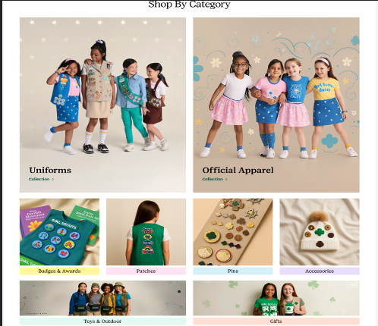

Business Questions
The tagging here will answer these questions.

- Which categories are most clicked from the homepage?
- Does tile position influence CTR (position bias)?
- Which categories drive downstream conversion and revenue?
- Which homepage merchandising modules drive the most engagement vs hero vs nav?
- Do users prefer “Shop by Category” vs search vs navigation?
- Are certain categories underperforming and candidates for redesign/reorder?

Implementation Details
Add data-analytics-*
- The module container (for impressions)
- For Button (for clicks)

Impression
Attribute | Data Type | Requirement / Rule | Example
data-analytics-type | string | Required. Must use controlled taxonomy value (e.g., category_grid, category_selector, cta). | "impression"
data-analytics-kind | string | Required. Defines business intent (merchandising, promo, utility, content). | "merchandising"
data-analytics-location | string | Required. Logical page placement using standardized naming convention. | "homepage"
data-analytics-module | string | Required. Functional grouping name. Lowercase, underscore-separated. Must be consistent across child elements. | "shop_by_category"
data-analytics-label | string | Required. Human-readable slug describing module. Lowercase, hyphen-separated. | "uniforms|official_apparel|badga|" list all categories in the module
data-analytics-id | string | Required. Globally unique identifier for governance and long-term reporting stability. | "module_shop_by_category"

Clickable items

Attribute | Data Type | Requirement / Rule | Example
data-analytics-type | string | Required. Must use controlled taxonomy value (e.g., category_tile). | "cta"
data-analytics-kind | string | Required. Defines intent (merchandising, promo, utility, content). | "merchandising"
data-analytics-location | string | Required. Logical page placement using standardized naming. | "homepage"
data-analytics-module | string | Required. Must match parent module wrapper exactly for attribution. | "shop_by_category"
data-analytics-position | integer | Required. Positive integer. Position within module starting at 1; sequential across tiles. | 1
data-analytics-label | string | Required. Lowercase, hyphen-separated slug representing the tile value. | "uniforms"
data-analytics-id | string | Required. Globally unique and stable identifier. | "cat_uniforms"
data-analytics-destination | string (URL path) | Required. Must match href destination for validation/reporting. | "/shop/uniforms"

Impression:

<section
data-analytics-type="category_grid"
data-analytics-kind="merchandising"
data-analytics-location="homepage"
data-analytics-module="shop_by_category"
data-analytics-label="uniforms|official_apparel|badges_awards|patches|pins|accessories|toys_outdoor|gifts
data-analytics-id="module_shop_by_category
>
Clickable items:
<a
href="/shop/uniforms"
data-analytics-type="category_tile"
data-analytics-kind="merchandising"
data-analytics-location="homepage"
data-analytics-module="shop_by_category"
data-analytics-position="1"
data-analytics-label="uniforms"
data-analytics-id="cat_uniforms"
data-analytics-destination="/shop/uniforms"
>
Uniforms
</a>

